## CHERRY IN LINE

**Chapter 5**

**Findings, Results, and Analysis**

5.2 Electrical Audit

5.2.2 Short circuit calculation

**1) CALCULATION CONSIDERATIONS**

# ***Software used***

* Software used is ETAP (Electrical Transient Analyzer Program) version 16.2 licensed under Alternative Power Solutions inc., is the most comprehensive solution for the design, simulation , and analysis of generation, transmission, distribution, and industrial system.

# ***Available MVA Short Circuit***

* Utility supplying normal power to this pump station via a 34.5 KV line is MERALCO (Manila Electric Co.). The maximum projected fault at this pump station is to be requested by the owner from the utility. In the calculation, 500MVA available short circuit was used.

# ***Transformers***

* Short Circuit Calculation was based on a **3 x 50kVA transformer** feeding the transfer switch going to the motors. Transformer impedance used in the calculation is per standard impedance in the absence of data.

# ***Generator set***

* Emergency power will be supplied by 1 Genset, rated at 110 kVA feeding the transfer switch busduct to synchronizing panel
* The result of the short circuit value of four generator sets is slightly lower than the short circuit fault value produced on the bus during normal power mode. Subtransient value of the generator should be provided for a more accurate calculation.

***Length of wires and cables***

* Length of cables and wires were derived from actual measurement. These values were used for the short circuit calculation.

**2) SUMMARY OF SHORT CIRCUIT CALCULATION**

|  |  |  |  |  |
| --- | --- | --- | --- | --- |
| **ITEM NO.** | DESCRIPTION | CALCULATED SHORT CIRCUIT | AS FOUND kAIC EXISTING CB | REMARKS |
| A. | THREE PHASE |  |  |  |
| 1. | 3 X 50 kVA TRANSFORMER-SECONDARY | 2.479kA | - | PROTECTION VIA FUSE PROVIDED BY UTILITY |
| 2. | TRANSFER SWTICH | 2.418 kA | 18 kA | EXISTING ACCEPTABLE |
| 3. | MAIN MCCB 250A @460 | 2.418 kA | 18 kA | EXISTING ACCEPTABLE |
| 4 | FEEDER MCCB-1 100A (30HP MOTOR) | 2.391 kA | 8 kA | EXISTING ACCEPTABLE |
| 5. | FEEDER MCCB-2 100A (30HP MOTOR) ALTERNATE | 2.391kA | 8 kA | EXISTING ACCEPTABLE |
| 6. | MOTORIZED OPENING VALVE SUPPLY 1 | 2.391 kA | 8 kA | EXISTING ACCEPTABLE |
| 7. | MOTORIZED OPENING VALVE SUPPLY 2 | 2.391 kA | 8 kA | EXISTING ACCEPTABLE |
| 8. | MOTOR1 -30HP | 0.143 kA | - | PROTECTION VIA VFD |
| 9. | MOTOR2-30 HP | - | - | ALTERNATE |
|  | SINGLE PHASE |  |  |  |
| 1. | MCCB 30A | 2.041 kA | 2.5 kA | EXISTING ACCEPTABLE |
| 2. | DRY TYPE TRANSFORMER 2.5 kVA | 0.411 kA | - | PROTECTION VIA UPSTREAM MCCB |
| 3. | MCB 32A UPS (LUMP 3) | 0.3964kA | 2.5 kA | EXISTING ACCEPTABLE |
| 4. | MCB 32A LIGHT & CONV OUTLET (LUMP 4) | 0.394 kA | 2.5 kA | EXISTING ACCEPTABLE |
| 5. | MCB 32A FOR METER (LUMP 5) | 0.394 kA | 2.5kA | EXISTING ACCEPTABLE |
|  |  |  |  |  |

3. Three phase short circuit calculation

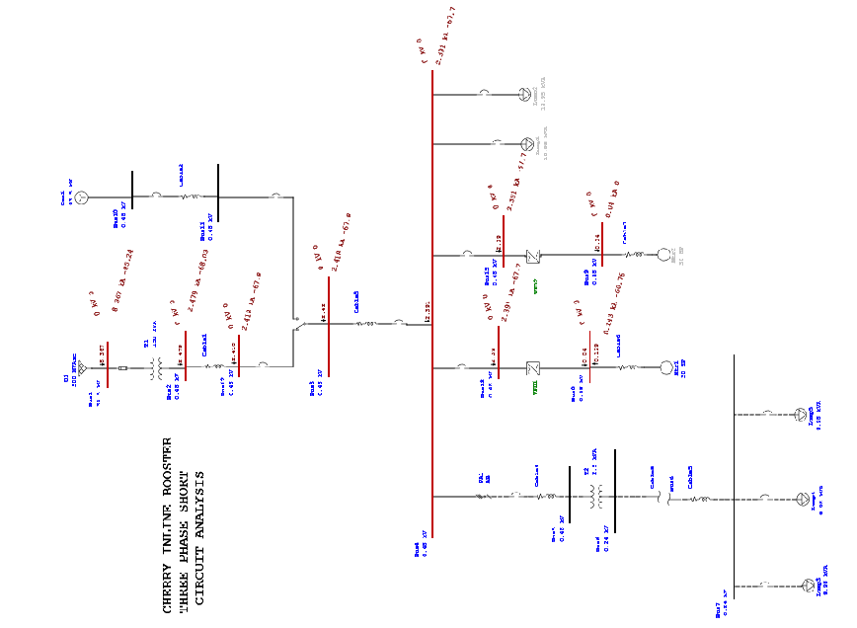

4. Single phase short circuit calculation

